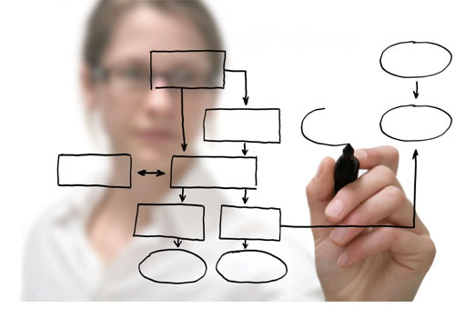

Author: Angela Shephard

8/12/2014

Project Management 101

**Table of Contents**

Lesson 1: Fundamentals of Project Management

Lesson 2: Key Terms

Lesson 3: Triple Constraint Mode

L

Lesson 4: PMI Methodology & Project Life Cycle

Lesson 5: Stakeholders (Roles & Responsibilities)

Lesson 6: Feed the Children’s Project Initiation Process

Lesson 7: Discovery & Scope Statement

Lesson 8: Key Subsidiary Plans

Lesson 9: Plans (Project, Communications & Quality)

**Lesson 1 - Fundamentals of Project Management**

In this section of our training we will discuss the basic principles of project management.

**Learning Objectives:**

* Provide definition of key terms
* Explain the difference between a “project” and “process”.
* Provide staff information on how Strategic Planning & Performance can provide assistance to their departments with projects.

**Project Management**

Prepare PM defines **project management** as the application of knowledge, skills, tools and techniques to project activities in order to meet project requirements.

**The Difference between a Project and a Process or Program**

The difference between a project, process and a program can be understood in terms of the length and scope of assigned activities.

For example, a project is *temporary* in nature and has a *start and end date*. Unlike a process or program, which is *ongoing* operations that are repetitive, permanent or semi-permanent functional activities to produce products or services.

**Lesson 2 - Key Terms**

**Project:** The PMI (Project Management Institute) defines a **project** as a temporary group of activity designed to produce a unique product, service or result.

**Milestone:** The PMI (Project Management Institute) defines a **milestone** is a significant event in a project that occurs at a point in time.

**Baseline:** The project baseline is used to track the progress of a project. It’s often referred to as the due date on a project.

**Objective:** A high level goal and success criteria. SMART = Specific, Measureable, Attainable, Relevant, Time-bound.

**Lesson 3 - Project Constraints**

In this section of our training we will discuss project constraints, their relation and how they impact the overall success of projects.

**Learning Objective**:

* + Gain a good understanding of what a constraint is and how to managing constraints through effective planning.
  + Discuss all three attributes that make up the triple constraint model.

**Most Common Constraints**

**Scope**: How much work is to be done? Increasing the scope causes more work.

**Quality**: What quality standards are required for the project? Higher quality requires more work and also impacts other constraints.

**Schedule**: The time required to complete the project. Changing start and end dates for tasks can impact the projects timeline and overall due date.

**Resources**: How many resources are available to perform the work required for the project? Not enough resources can impact the timeline but adding additional resources can impact the budget.

**Risk**: Decisions made during planning and execution can often be associated with a level of risk. Some risker than others that can affect other constraints.

**TRIPLE CONSTRAINT MODEL**

Each constraint in this model directly impacts the other.

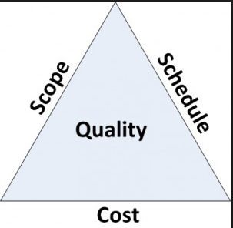

**Lesson 4 - Project Life Cycle**

In this section of our training we will discuss the basic principles of project management.

**Learning Objectives**:

* + Discuss the 5 phases of a project
  + Review the Project Life Cycle model
  + Review Feed the Children’s Project Initiation Process

PMP Methodology (Framework & Process Groups)

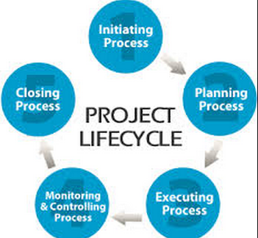

* **Initiation**: Defines the project objectives and grants authority to the project manager.
* **Planning**: Refines the project objectives and scope and plans the steps necessary to meet the project’s objectives.
* **Execution**: Puts the project plan into motion and performs the work of the project.
* **Monitoring & Controlling**: Measures the performance of the executing activities and compares the results with the project plan.
* **Closing**: Documents the formal acceptance of the project’s product and brings all aspects of the project to a close.

**Lesson 5 - Project Team, Roles & Responsibilities**

In this section of our training we will discuss the basic principles of project management.

Learning Objectives:

* + We will define project sponsor, stakeholders and their roles and responsibilities.
  + Review the RACI Model

**Project stakeholders**: Can be defined as anyone having a vested interest in the project.

**Project Team**: Consists of all members and is not limited to “core” team members.

**Project Sponsor**: Provides financial resources for the project. Also, promotes and supports the project. The sponsor is the final approver on a project.

**Product/Business Owner**: Often referred to as the “customer” assists team in defining objectives and gathering business requirements. The business owner is granted authority by the sponsor to make important decisions on a project but the final approver is always the project sponsor.

**Project Manager**: Responsible for managing the project. Key responsibilities include but are not limited to the following:

* Building a team
* Maintaining project documents
* Conflict management
* Developing project plan
* Reviewing milestones and deliverables
* Scheduling activities and resources

Our department provides additional assistance on project such as process mapping, meeting facilitation, development of training materials, business process review and GAP analysis.

**Basecamp**: Is a tool used as for project management.

It provides a place for team members to collaborate, share materials and track milestones.

It’s a great tool when used properly and serves as a (single source) for project information and shared communications.

For more information on Basecamp please visit: <http://www.basecamp.com> or sign up with Strategic Planning and Performance for a walkthrough on how to use the tool.

RACI Model

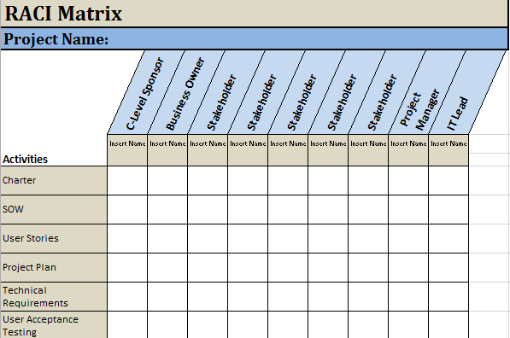

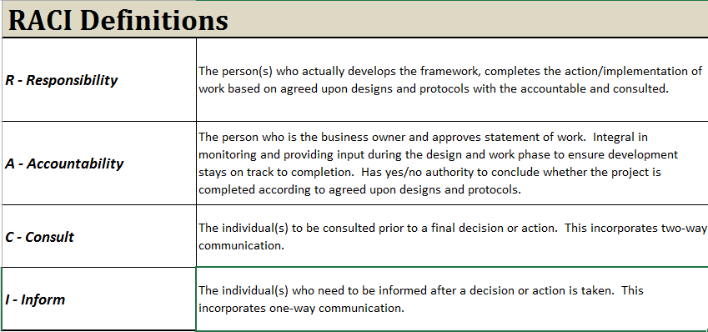

**Lesson 6 - Project Initiation Process**

**What is Project Initiation?**

It is the process of initiating and defining a project. In this phase you establish your objectives and the expected outcomes, define the scope, determine impacted business processes, obtain buy-in from the executive team, and establish priorities and ensure alignment with the strategic plan. It is the most critical phase in a project. Projects cannot be successful without properly being defined.

Project Initiation provides a consistent process to be used across all departments. It ensures that all projects are aligned with the strategic plan and project teams and impacted stakeholders are identified.

**What is a Corporate Project?**

A Project is temporary in nature and has a definite beginning and end date. It is usually time constrained and often constrained by funding or deliverables. A Project is undertaken to meet unique goals and objectives to bring about change or added value.

**Project vs. Ongoing Operations**

The temporary nature of projects stands in contrast with ongoing operations or business as usual. Ongoing operations are repetitive, permanent, or semi-permanent functional activities to produce products or services.

**When Do I Follow This Process?**

Most departments have internal projects that apply to only their department and do not positively or negatively impact another department. These projects do not need to follow this process. Projects that meet at least one of the following requirements must follow the steps outlined in the Process Definition.

1. A Project that positively or negatively impacts another department
2. A Project that requires work from another department

**Examples**

Included below are examples of existing projects and ongoing operations for your reference.

| **ONGOING OPERATION / PROGRAM** | **PROJECT** |
| --- | --- |
| American’s Feeding Americans | Implementation of new model of American’s Feeding American’s |
| Inventory Audits | Check By Phone |
| Annual Report | Implementation of automated Performance Review Process |
| Annual Strategic Plan Updates | Online Agency Feedback Form |
| Child Sponsorship | Modify Child Sponsorship Form and Process |

**Process Definition**

The following steps have been outlined for the organization to follow a consistent process across all departments. There are exceptions to this process and those will be handled on a case by case basis. This process serves three purposes: defines the project, obtains buy-in from executive team, and engages impacted stakeholders.

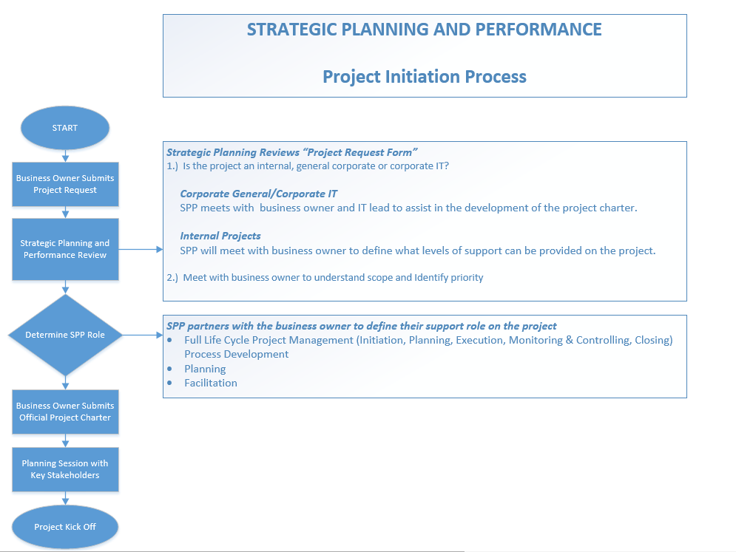

Go to the intranet: departments/strategic planning & performance to locate the project request form and the project charter.

Get additional support online at: angelashephard.wix.com/feedelearning

**Example of Project Charter**

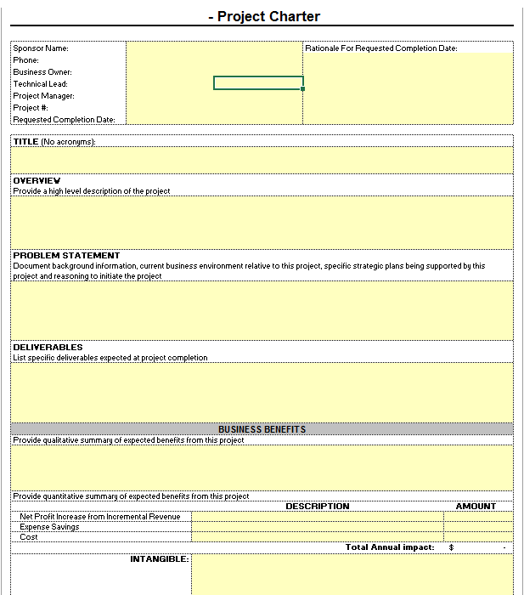

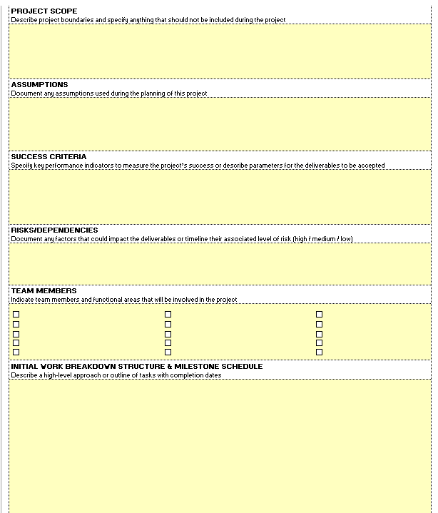

**Lesson 7 - Scope Management**

Scope Management is the set of processes that ensures that requirements of the business owner or customer are captured in a specification of work that ensures delivery of project deliverables.

**Project Discovery**

Project discovery takes place during the initiation phase and continues during into the beginning stages of the planning phase.

During discovery the two key action items are:

1. Ask questions
2. Document (Needs, Expectations)
3. Benefits

***Determine the Need***

It’s critical to determine the need that is driving the project.

PMPBOK Guide provides the following suggestions for obtaining this type of information:

* Market Demand (supply and demand)
* Business Need (a new course to increase revenue)
* Customer Request (electric company builds a station to serve new area)
* Technological Advances (firm upgrades software for compatibility)
* Legal Requirements (establish guidelines for handling toxic materials)
* Social Need (water well development in low-income countries)

***Define Scope: What’s the End Product or Service***

Scope defining is a creative process that clearly states what the project will and will not accomplish.

Items that should be included in the statement:

1. Determine business requirements (features or specifications). Identify what is “mandatory and optional”.
2. Clearly communicate the stakeholder’s expectations.

Collecting project requirements can be done through utilizing the following inputs, tools and techniques:

* Project Charter
* Stakeholder registry
* Interviews
* Focus Groups
* Workshops
* Group decision making
* Questionnaires and surveys
* Observations
* Prototypes

**Project Scope Statement**

Writing an effective scope statement is a critical key in your projects success. Many project experience what’s called “***scope creep***” due to lack of planning and not having a clear understanding of the projects scope.

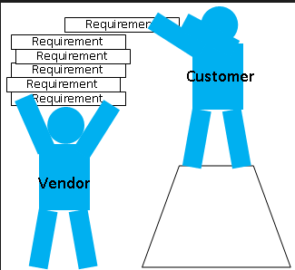

**Scope Creep** occurs after a project has started and the actual scope of the project changes. The customer will often times decide include additional requirements to a projects scope which can impact one of the constraints that we discussed earlier. More, commonly impacting cost, scope or quality.

*\*\*Note: When this happens the project manager should request the customer to submit a “change request” so that the project impact and risks can be evaluated.*

**Lesson 8 - Plans**

**Project Plan**

A Project plan is a tool used to track project milestones and tasks. It also identifies responsible parties and measures the projects overall performance.

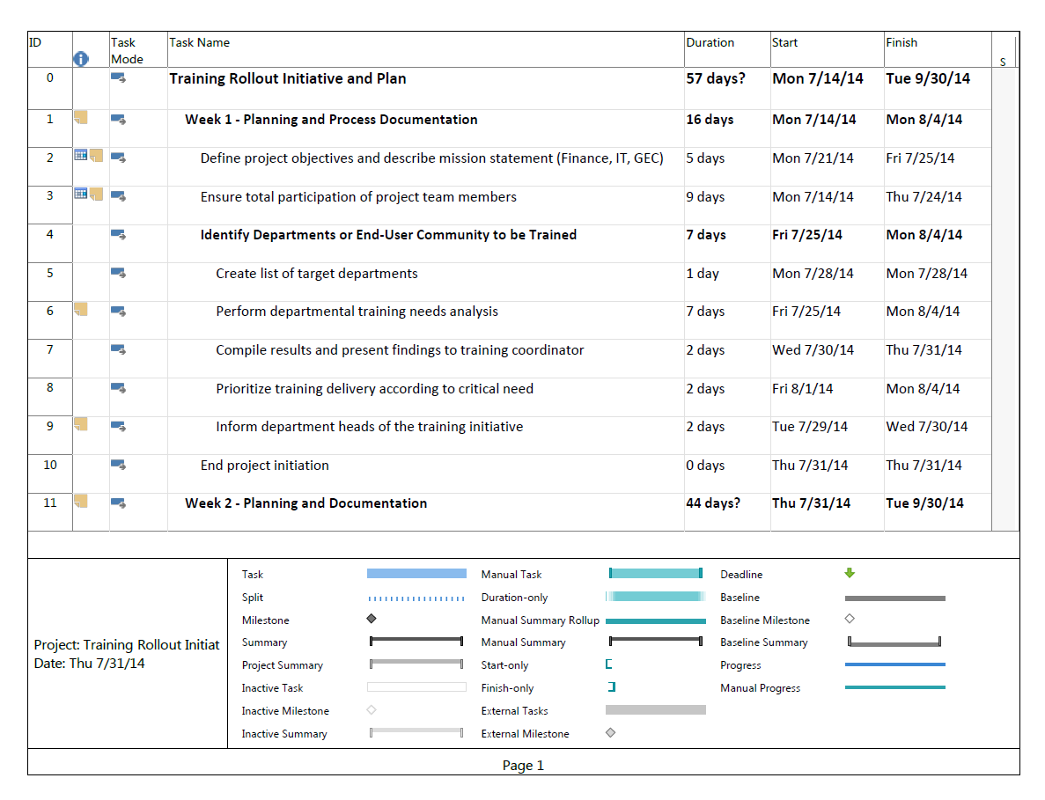

**Communications Management**

Includes the processes required to ensure timely and appropriate generation, collection, distribution, storage, retrieval of project information.

There are a total of 5 processes required for managing project communications.

These processes are identified below with their respective group in a projects life cycle.

|  |  |
| --- | --- |
| Identify Stakeholders | Initiation Process Group |
| Plan Communications | Planning Process Group |
| Distribute Information | Execution Process Group |
| Manage Stakeholder Expectations | Execution Process Group |
| Report Performance | Monitoring & Controlling Process Group |

Effective communication creates a bridge between diverse stakeholders involved in a project, connecting various cultural and organizational backgrounds, different levels of expertise, and various perspectives and interests in the project execution or outcome.

Project communications should be a coordinated effort by all team members.

The project managers spend the majority of their time communicating with team members and other project stakeholders, whether they are internal (at all organizational levels) or external to the organization.

Methods of communication can be any or all of the following:

* Formal (reports, memos, briefings) and informal (emails, discussions
* Vertical (up and down the organization) and horizontal (with peers)
* Official (newsletters, annual report) and unofficial communications)
* Written and verbal communications

Skills required for effective communication management:

* Listening actively and effectively
* Questioning, probing ideas and situations to ensure better understanding
* Educating to increase team's knowledge so that they can be more effective  
  Fact-finding to identify or confirm information
* Setting and managing expectations
* Negotiating to achieve mutually acceptable agreements between parties
* Resolving conflict to prevent disruptive impacts
* Summarizing, recapping, and identifying the next steps

**Communications & Training Plans**

A **communications plan** is contained as a subsidiary of the project management plan and can be either formal or informal in nature.

It is an output created by the project manager for project team members providing information on how information will be communicated during the life cycle of the project.

It can also include templates and guidelines for project communications. Such as, status reports, emails, use of a project website such as Basecamp, etc.

A **training plan** is also contained as a subsidiary of the project plan. The purpose of this plan is to capture high level tasks needed to prepare for the training any training required internally and externally for successful implementation of the project.

**Note: Examples of both communication and training plans are provided below.

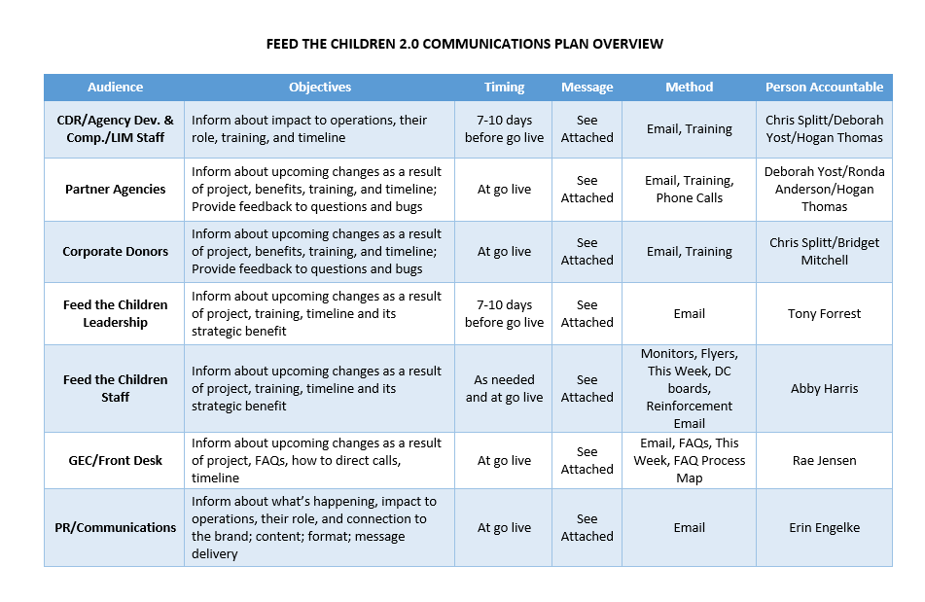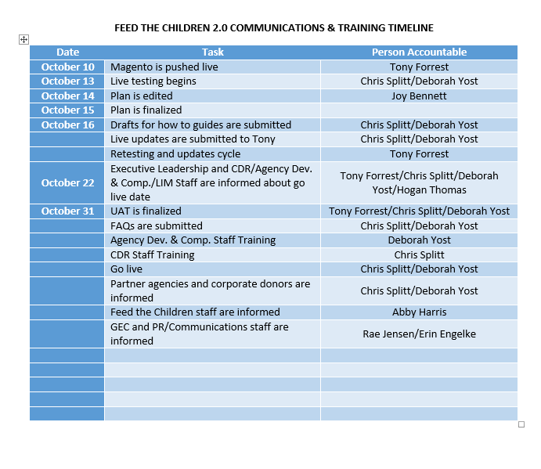

**Quality Management**

Quality management is another subsidiary of the project management plan. It describes how the team will implement the quality policy. It addresses quality control, assurance and continuous improvements. Below is a breakout of the three areas of focus with regards to quality management.

|  |  |  |  |
| --- | --- | --- | --- |
| Knowledge Area | Process Group | Tools & Techniques | Primary Outputs |
| Quality Planning | Planning Process Group | Identifies which standards are relevant to the project and determines how to establish them. | Benefits Analysis  Quality Metrics  Quality Improvement Plans |
| Perform Quality Assurance | Monitoring & Controlling Process Group | This process area is reviewed during the monitoring and controlling phase of a project and is often referred to as User Acceptance Testing. | Change Management (changes and corrections) |
| Perform Quality Control | Monitoring & Controlling Process Group | Monitor results and track any areas of concern through resolution. | Quality Performance Review  Validation of Defects  Recommendations  Requested Changes  Validated Deliverables |

**Note: During **quality assurance** users will test policies, procedures and technology to ensure it meets the needs of the business and works as designed.

The business owner and sponsor must sign off on the completion of user acceptance testing. This ensures that the product that was tested does meet the needs of their business and is working as designed.

**Lesson 11 – Project Closure**

Once all change requests have been processed and user acceptance testing has completed the project should be reviewed for any outstanding tasks or milestones. If all tasks and milestones are completed it is ready to transition from active to closed.

Prior to officially closing a project, the project manager will get authorization from the sponsor and business owner.

Once authorization is received project closure activities will kick off. Such as any or all of the following:

* A communication will be sent to the team advising that the project is closing.
* Retrospective meeting scheduled.
* Post Project Survey sent to stakeholders.
* Basecamp action items are closed out and folder is archived.